# Role Description

## Job Title: Duty Manager

## Reports to: Operations Manager

## Job context

Uppingham School, founded in 1584, is a leading co-educational independent boarding school which runs 24/7 in term-time. It has a strong academic profile and excellent pastoral care with an international reputation, and state-of-the-art science, sports and music facilities. Its 830 pupils, aged 13-18, are accommodated in 15 boarding houses, taught by over 20 academic departments, and participate in numerous extra-curricular activities such as sports, music, and drama. The academic programme is supported by business units responsible for marketing, estates, finance, HR, IT, operations (catering, cleaning, and procurement), health and safety, and the School’s trading subsidiary. The School employs c. 550 staff.

Opened in September 2010, Uppingham School Sports Centre (‘USSC’) is a fully dual-use facility and used by 1,300 public members as well as the School. Described by Lord Coe at its opening as ‘world class’, USSC has been designed to provide state-of-the-art sporting facilities for the school’s pupils, as well as allowing access to local residents, sports clubs, and other schools.

The Centre contains a 6-court sports hall, 25m swimming pool, 60 station fitness studio, gymnasium, squash courts and dance studios. The fitness studio was fully re-equipped in December 2021. It also houses the School’s PE Department and includes a hospitality suite for match-day entertaining. USSC is managed and run-on behalf of the School by Uppingham School Enterprises Ltd, a wholly owned subsidiary, and employs c. 40 full- and part-time staff.

## Job purpose

To provide all visitors to Uppingham School Sports Centre with a friendly and positive experience, through delivering effective customer service and maintaining safe and efficient facilities through supervision of all shift staff.

## Your accountabilities

**General**

1. Completing your shift in accordance with the rota and completing daily task sheets.
2. Ensuring all staff fulfil their daily tasks / duties.
3. Ensuring all sporting facilities and equipment are suitable for use.
4. Supervise pupils and members/visitors and ensure their safety.
5. Undertake regular staff training including maintaining your NPLQ.
6. Adhere to all the companies’ written policies and procedures.
7. Manage individually allocated areas of responsibility reporting progress to the Operations Manager and other HOD’s as required.
8. Assist the Operations Manager in the training and development of Leisure Assistants and other staff.
9. Manage short term rota, making sure shifts are covered when there is holiday/sickness.
10. Cover breaks on a regular day to day basis in fitness and reception.

**Personal Deportment**

1. Represent the company when on site in the appropriate manner, including while arriving and departing the site.
2. Wear the appropriate uniform and comply with the code of conduct in the Staff Handbook.
3. Respect your colleagues by meeting common goals and standards.

## Main Duties

**Customer Service**

1. Promote quality customer service at all times, dealing with comments and reporting more serious issues to the Centre Manager.
2. Ensure all lost property is handled and recorded in line with written procedures.
3. Provide information and assistance to customers or direct them to reception.
4. Pupils, staff and the public are all customers of the Centre and must be recognised as such.

**Facility Management**

1. Maintain the security of the building at all times including the opening and closing of the centre on a daily basis.
2. Complete cash reconciliations with receptionists and ensuring all financial and banking procedures are followed.
3. Ensure all daily tasks are completed and recorded.
4. Ensure all Health & safety procedures are followed at all times.
5. Completed regular checks of all building plant including pool and make adjustment as necessary.
6. Carry out fire alarm testing in line with NOP.
7. Respond to all emergency situations quickly and effectively.
8. Follow planned maintenance programmes and report / follow up any defects.
9. Play an effective role in the training of other staff members.

**Sales**

1. Undertake and complete the membership sales process.
2. Promote activity schemes and sale promotions.
3. Compile income & expenditure reports for your allocated areas of responsibility as requested by your line manager.

**General**

1. Liaise with managers to focus on ways to improve the Centre.
2. You will be required to cover other departments during your working hours. (i.e. reception, fitness suite etc)
3. Undertake any reasonable request as specified by the Operations Manager for which you are trained.
4. Respond to out of hours alarm call outs.
5. Put together a weekly report on given areas of responsibilities and deliver progress updates to the rest of the management team.

**Qualifications, skills and experience, personal qualities required**

**Qualifications:**

* NPLQ
* First Aid
* Desirable Fitness Instructor (level 2)
* Desirable SEQ Swim Teacher (level 1 or 2)
* Desirable Pool Plant Operator

**Skills and experience:**

* Experience of working within the leisure industry
* Experience of working as part of a team
* Experience of staff supervision
* Experience of dealing with emergency situations
* Desirable to have experience of using membership information systems.
* Desirable to have previous plant room management experience.

**Personal qualities:**

* Calm manner
* Approachable
* Flexible
* Confident when dealing with people.
* Able to lead a team.
* Able to use own initiative.

## Key relationships

**Sports Centre personnel:**

* **Sports Centre Manager**
* **Operations Manager:** Duty Managers, Leisure Assistants, Course Instructors, Activity Co-ordinator, Swimming Teachers
* **Fitness Manager:** Fitness Instructors, Personal Trainers, Studio Co-ordinator, Class Instructors
* **Front of House Manager:** Receptionists

## Terms and conditions

**Working hours** Average of 40 hours per week.

3 week rolling rota to cover the opening hours of 7am-10pm Monday to Friday, 8am-6pm Saturday & 8am-10pm Sunday along with flexi shifts which should be timed to reflect the needs of the business.

**Probation period** 6 months

## Benefits

**Holidays** The annual holiday entitlement is 28 working days. Bank/Public holidays when the Centre is open are normal working days. Payment for all Bank/Public holidays is included in the salary above.

**Pension scheme** Defined contribution scheme: employee contribution matched by USE Ltd by factor of two, up to 10% maximum.

**Benefits** Free membership of dual-use Sports Centre (£25 annual joining fee)

Free staff lunches in term-time

50% contribution to premiums for School’s private health scheme

Westfield Health Scheme providing money back for various treatments, including optical and dental.

Retail, gym, supermarket, cinema, and restaurant discounts

Cycle to work scheme.

Employee Assistance Programme which provides a range of support including counselling and legal advice

Occupational Health Services

Free annual ‘flu jabs’

Recognised as a “Disability Confident” employer.

Recognised as a “Mindful” employer.

Working towards “Investors in Diversity.

## Organisation chart

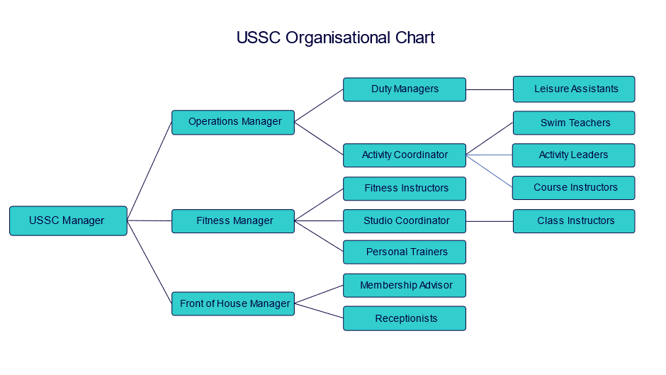

## Safeguarding

Uppingham School is committed to safeguarding and promoting the welfare of children. Successful candidates must be willing to undergo full screening in accordance with Keeping Children Safe in Education (KCSiE), including an Enhanced Disclosure and Barring Service check. Issues relating to safeguarding and promoting the welfare of pupils will be explored at interview.

## Note

This Role Definition is not an exhaustive list of what may be expected of you in the role. It is non-contractual and may be amended by the school from time to time.

**Applications**

Applicants should complete the School’s application form, which can be obtained from the website ([www.uppingham.co.uk](http://www.uppingham.co.uk)) and returned, when completed, to [hr@uppingham.co.uk](mailto:hr@uppingham.co.uk), 01572 822216.

The HR Department

Uppingham School

High Street West

Uppingham

Rutland

LE15 9QD