# Job Description

## Job Title: Ledgers Administrator

## Reports to: Finance Manager

## Job context

Uppingham School, founded in 1584, is a leading co-educational independent boarding school. It has a strong academic profile and excellent pastoral care with an international reputation, and state-of-the-art science, sports and music facilities. Its 840 pupils, aged 13-18, are accommodated in 15 boarding houses, taught by over 20 academic departments, and participate in numerous extra-curricular activities such as sports, music, and drama. The academic programme is supported by business units responsible for marketing, estates, finance, HR, IT, operations (catering, cleaning, and procurement), health and safety, and the School’s trading subsidiary.

In term-time (about 32 weeks each year) the School operates seven days per week. In the Easter and summer months it operates a commercial lettings business. The School employs c. 550 full-time and part-time staff in about 40 different professions, among whom the teachers report to the Headmaster and the business support staff to the Bursar. The School is a company limited by guarantee and a registered charity and governed by 20 voluntary Trustees who are responsible for guiding the Headmaster and Bursar in matters of governance and strategy.

The estate covers 125 non-contiguous acres, almost one mile apart at its extremities and interspersed by town housing and retail properties. It includes 59 acres of playing fields, 14 acres of gardens, and a built estate of 80 buildings, mostly large, many old, and 23 with listed status. Buildings include teaching blocks, assembly buildings, boarding houses, staff housing, administrative and technical accommodation, sports facilities, a dual-use Sports Centre and a commercial theatre.

The Uppingham Group of Schools also includes Maidwell Hall School in Northamptonshire, which educates pupils from ages 4 to 13, and Uppingham School Enterprises Ltd (Uniform Shop, Sports Centre and external lettings). Uppingham Cairo will open in 2024, with Uppingham Vietnam planned for the following year.

The finance team of eleven staff (nine full time equivalent) is responsible to the Finance Director and works in Financial Operations, Financial Management and Payroll.

Uppingham is committed to Equality, Diversity and Inclusion and welcomes applications from anyone who feels they could fulfil the role.

## Job purpose

To provide accurate and efficient management of (1) the School’s purchase ledger including maintaining supplier data, processing supplier payments and invoices, managing petty cash and reconciling bank accounts and (2) the termly fee billing process, including invoice production.

This role is a job share with the Ledgers Assistant; the Ledgers Administrator has primary responsibility for delivering the required outputs (e.g. the termly fee bills) and for coordinating the workload between the two positions.

## Your duties

1. **Purchase ledger**: distributing purchase invoices to budget holders for authorisation and coding; managing the collation and accurate posting of purchase invoices and expense claims onto the ledger with the assistance of the two part-time receptionist/accounts assistants, resolving queries as they arise; reconciling monthly suppliers statement and resolving any differences; preparing a weekly BACS payment file for authorisation and processing by the Finance Director; reconciling the purchase ledger control account on a monthly basis.
2. **Fees ledger:** processing pupil extra charges as and when received including reconciling extras accounts to ensure all recharges have been processed; preparing and despatching termly fee bills to parents and publishing on the Parent Portal; once per term, emailing statements to parents; responding to parent billing queries, investigating and resolving queries, liaising with relevant teaching and support staff as necessary; reconciling the fees ledger control account on a monthly basis.
3. **Banking and petty cash:** banking and posting fee receipts and entrance deposits as and when received, screening for money laundering flags and obtaining further information as appropriate; posting all debit transactions on the bank statement to the nominal ledger; administering the petty cash system and reconciling on a monthly basis.
4. **Data collection and utilities invoicing**: maintaining a log of utilities and water bills for residential properties and invoicing tenants accordingly; monitoring council tax and business rates billing; maintaining log of mileage claims and fuel purchases for SECR reporting purposes.
5. **Credit cards**: administering credit cards, submitting new applications, chasing up missing receipts and posting transactions from the monthly statements.
6. **Other accountabilities**: administering the private health scheme for pupils; reconciling the Old Uppinghamians subscriptions account on a termly basis; providing emergency cover for reception, in conjunction with other members of the Finance team

## Qualifications, skills and experience, personal qualities required

**Qualifications:**

* Maths and English (GCSE Grade C / 4 or above)

**Skills and experience:**

* Experience with data input, accounts payable and administration essential
* Strong IT skills including scrutiny and analysis of data
* Good organisational skills with the ability to manage and understand detailed information
* Strong communication and excellent teamwork

**Personal qualities:**

* Excellent verbal and written communication skills at all levels of the organisation
* Accurate with meticulous attention to detail
* Quick learner with the ability to follow instructions
* Positive, ‘can-do’ and forward-looking attitude, able to work in a busy environment, and with a strong personal work ethic
* Diplomacy and sense of humour

## Key relationships

* Ledgers Assistant
* Receptionists / Accounts Assistants
* Housemasters/mistresses, Heads of Department, other budget holders
* External suppliers
* Parents

## Terms and conditions

Working hours 28 hours (4 days) per week for 52 weeks per year

Salary £21,700 (FTE £27,000)

Probation period 6 months

## Benefits

Holidays The annual holiday entitlement is 30 working days pro rata, of which up to 5 days must be taken over the Christmas period. Public holidays in term time are normal working days; a day off in lieu is given at another time.

Pension scheme Defined contribution scheme: employee contribution matched by School by factor of two, up to 10% maximum.

Benefits 50% Contribution towards premiums for the School’s private health scheme

Discount on School fees

Discount at a local nursery in Uppingham

25% Discount on holiday club fees for children of Uppingham or Maidwell Hall staff

Westfield healthcare

Westfield Rewards which gives discounts at various retailers, gyms, cinemas, and restaurants

Contributory pension scheme

Employee Assistance Programme

In house Occupational Health Service

Membership to dual-use Sports Centre (with a £25 annual joining fee)

Free staff lunches during term-time

Free annual Flu vaccinations

Complimentary staff ticket for select School performances

Cycle to Work scheme

Recognised as a “Disability Confident” employer

Recognised as a “Mindful” employer

Recognised as “Investors in Diversity”

## Safeguarding

The post-holder’s responsibility for promoting and safeguarding the welfare of children and young persons for whom s/he is responsible, or with whom s/he comes into contact, will be to adhere to and ensure compliance with the School’s Safeguarding (Child Protection) Policy at all times. If in the course of carrying out the duties of the post the post-holder becomes aware of any actual or potential risks to the safety or welfare of children in the School s/he must report any concerns to the School’s Designated Safeguarding Lead or to the Headmaster.

## Organogram

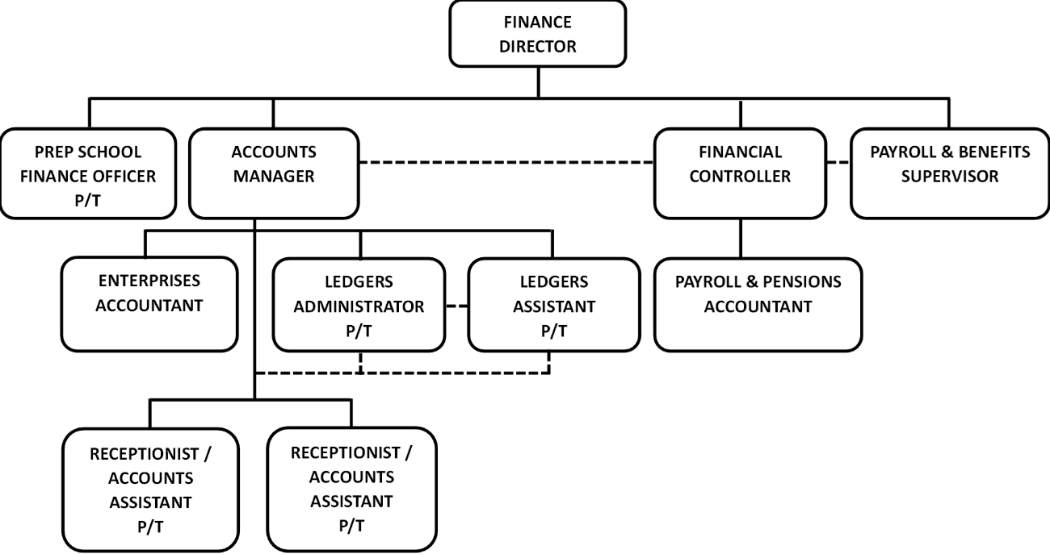

**Note**

This Role Definition is not an exhaustive list of what may be expected of you in the role. It is non-contractual and may be amended by the School from time to time.