Role Description

Job Title: Operations Manager

Reports to: Sports Centre Manager

Responsible for: Duty Managers, Activity Coordinator, Leisure Assistants

Job context
Uppingham School, founded in 1584, is a leading co-educational independent boarding school which runs 24/7 in term-time. It has a strong academic profile and excellent pastoral care with an international reputation, and state-of-the-art science, sports and music facilities. Its 830 pupils, aged 13-18, are accommodated in 15 boarding houses, taught by over 20 academic departments, and participate in numerous extra-curricular activities such as sports, music, and drama. The academic programme is supported by business units responsible for marketing, estates, finance, HR, IT, operations (catering, cleaning, and procurement), health and safety, and the School’s trading subsidiary. The School employs c. 550 staff.

Opened in September 2010, Uppingham School Sports Centre (‘USSC’) is a fully dual-use facility and used by 1,300 public members as well as the School. Described by Lord Coe at its opening as ‘world class’, USSC has been designed to provide state-of-the-art sporting facilities for the school’s pupils, as well as allowing access to local residents, sports clubs and other schools.

The Centre contains a 6-court sports hall, 25m swimming pool, 60 station fitness studio, gymnasium, squash courts and dance studios. The fitness studio was fully re-equipped in December 2021. It also houses the School’s PE Department and includes a hospitality suite for match-day entertaining. USSC is managed and run-on behalf of the School by Uppingham School Enterprises Ltd, a wholly owned subsidiary, and employs c. 40 full- and part-time staff.

Job purpose

To assist the Sports Centre Manager in the day to day management of the Sports Centre with the specialist responsibilities for cleanliness, maintenance, health and safety, staffing and training. You will operate with regard to all Health & Safety legislation, operational procedures and best practice.

Your accountabilities

General

- Assist the Centre Manger to prepare the department business plan and implement
- Ensure the whole Centre delivers a high quality customer-focussed service for all users.
- Promote the use of the Centre by all user groups to maximize use and income.
- Implement Normal Operating Procedures and Emergency Action Plans.
- Manage, achieve and strive to exceed delegated sales targets
- Manage operating costs and staffing to minimise expenditure
- Manage staff rotas, training and recruitment for Ops team
- Responsible for the presentation (Cleaning) of the centre
- Manage the Centre in a sympathetic manner to reflect the aims, ambitions and ethos of the school.
- Deputise for the Centre Manager and act as Duty Manager as part of a rota
- Undertake monthly review of sections of Normal Operating Procedures and Emergency Action Plans.
- Oversee cleaning standards and methods, Lifeguarding / Pool plant / Swim School
- Leisure Assistant / DM daily programme / Coordinate with Front Of House financial reconciliation / Cleaner daily programme
- Establish, source, deliver and record training
- Purchase equipment for delegated areas & place orders for necessary stock
- Liaise with the School maintenance departments to maintain an accurate library of information for maintenance programmes and operating manuals
- Manage the staff rota and cover for Leisure assistants’ & Duty Managers
- Manage the swim school with regard to planning, delivery, evaluation and performance
- Manage the centre bookings, secure new contracts and update accordingly

Financial
- Produce annual budget in line with the business plan for delegated income and expense codes (these include maintenance contracts, chemicals, insurance, licences and contracts, first aid provision and own staff wages)
- Complete the monthly payroll and annual leave information for hourly paid staff and forward to accounts
- Contribute information on
  - Price structures
  - Sales targets
- Control delegated budgets
- Manage floats and cash balances
- Balance float weekly
- Ensure correct cash handling and financial procedures are followed
- Monitor and report on key financial and operational benchmarks on:
- Wages costs
- Budget lines
- Health and Safety
- Cleaning & Maintenance
- Staff training
- Operational checklists

- Produce monthly invoices for external hire
- Ensure weekly cash up records are completed

  - Assist the other Department Managers and contribute towards the following Marketing and Sales efforts as a team following the triangulated management system:

Marketing and Sales (contribute towards the following)

- Produce marketing material for non-members activities e.g. holiday courses, swimming lessons, special events, press materials.
- Specifically responsible for parties, holiday courses and one off bookings
- Delegate sales responsibilities to staff
- Review sales targets and communicate action throughout the organization
- Assist in the production of the members and public timetable

Health and Safety

- Ensure appropriate risk assessments are in place and updated as necessary.
- Implement Normal Operating Procedures, Emergency Action Plans and Pool Safety Operating Procedures
- Conduct annual review of all RA’s, NOP’s and EAP’s with Centre and Fitness Manager
- Ensure Health and Safety checks are carried out on equipment and plant as per policy.
- Minimise potential accidents through good housekeeping through active participation and supervision.
- Promote the Centre’s Health and Safety policy with staff
- Ensure there is adequate pool supervision at all times
- Ensure the security of the premises at all times

Staff Management

- Work with Human Resources Department to recruit staff within recruitment policy guidelines
- Write and maintain up to date job descriptions, person specification and adverts for Duty Managers, Leisure Assistant, Swim Teachers and Activity Leaders
- Ensure staff are aware of their relevant duties and responsibilities and undertake them as required. Provide appropriate training where necessary
- Implement the triangulated management system
- Ensure the correct compliment of staff is available when required to provide the appropriate level of supervision
- Complete the monthly payroll administration for all hourly paid USSC staff
- Monitor and minimise absence
- Complete staff annual appraisals and performance reviews
- Manage mandatory training (FAAW, NPLQ weekly updates of process)
- Write and apply uniform and basic staff behavioural standards (Communication standards etc)
- Deputise for Centre Manager when he is on annual leave or otherwise absent from the Centre, namely to chair meetings and deal with immediate issues until the Centre Manager is back to deal with them

Operational Roles

- Undertake duty management shifts, leading by example
- Monitor maintenance programme and coordinate PMP and lettings with Manager to minimise downtime
- Supervise pool plant maintenance programme, pool hygiene and cleaning
- Ensure notice boards are relevant and up to date
- Chair Duty Management and Leisure Assistant meetings
- Supervise weekly emergency tests
- Working with the FOH Manager, supervise administrative process, daily cash balance, assist in the production and operational feasibility of the bookings diary and function sheets, Duty Manager handover and activity schedule
- Any other tasks duties that his/her line manager may reasonably request, including covering management responsibilities for other Department Managers and the Centre Manager during periods of absence.

Swim School & Activities

- Organise and manage the Swim School with the Activity Coordinatior
- Organise and manage the children’s activities with the Activity Co-ordinator
- Monitor the service and delivery of all department activity including all children’s activities and swim lessons.

Personal Deportment

- Represent the company when on site in the appropriate manner, including while arriving and departing the site.
- Wear the appropriate uniform and comply with the USSC Code of Conduct
- Respect your colleagues by meeting common goals and standards.

Qualifications, skills and experience, personal qualities required

Qualifications:

- NPLQ
- First Aid at Work
- Pool Plant Operators Certificate
- Desirable Fitness Instructor (level 2)
- Desirable SEQ Swim Teacher (level 1 or 2)

Skills and experience:

- At least 2 years’ experience in a leisure facility as senior duty manager or higher
- Financial management and budget experience
- In depth knowledge of leisure facility programming
- Pool plant and general maintenance knowledge
- Strong IT literacy
- Good communication skills: meetings, presentations, reports
- Good people management skills and leadership qualities
- High standards of customer service
- Able to set targets and motivate staff to surpass them
- Knowledge of life saving and swimming teaching qualifications and related training

Personal qualities:

- Calm manner
- Approachable
- Flexible
- Confident when dealing with people
- Able to lead a team
- Able to use own initiative
- Ability to work flexible hours including shift system over a 7 day week
- Prepared to take a hands-on approach and step in when needed

Key relationships

Sports Centre personnel:
- Sports Centre Manager
- Operations Manager: Duty Managers, Leisure Assistants, Course Instructors, Activity Co-ordinator, Swimming Teachers
- Fitness Manager: Fitness Instructors, Personal Trainers, Studio Co-ordinator, Class Instructors
- Front of House Manager: Receptionists

Organisation chart

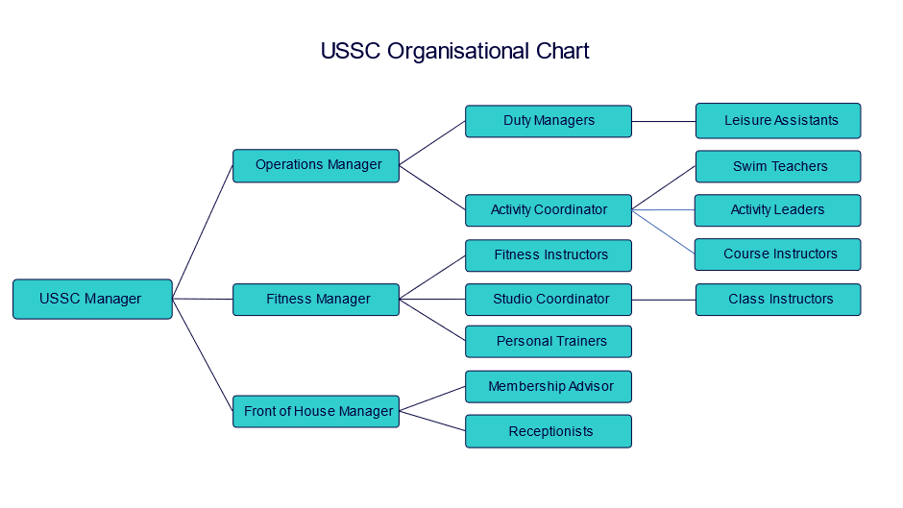

Terms and conditions

Working hours Actual working hours and days are to be confirmed but will be no less than 40 hours per week. Evening and weekend work is also necessary in this role.

The Operations Manager will also work 1 weekend in 4.

Probation period 6 months

Benefits
Holidays The annual holiday entitlement is 28 working days. Bank/Public holidays when the Centre is open are normal working days. Payment for all Bank/Public holidays is included in the salary above.

Pension scheme Defined contribution scheme: employee contribution matched by USE Ltd by factor of two, up to 10% maximum.

Benefits 50% Contribution towards premiums for the School’s private health scheme
Discount on School fees
Discount at a local nursery in Uppingham
25% Discount on holiday club fees for children of Uppingham or Maidwell Hall staff
Westfield healthcare
Westfield Rewards which gives discounts at various retailers, gyms, cinemas, and restaurants
Contributory pension scheme
Employee Assistance Programme
In house Occupational Health Service
Membership to dual-use Sports Centre (with a £25 annual joining fee)
Free staff lunches during term-time
Free annual Flu vaccinations
Complimentary staff ticket for select School performances
Cycle to Work scheme
Recognised as a “Disability Confident” employer
Recognised as a “Mindful” employer
Recognised as “Investors in Diversity”

Safeguarding
Uppingham School is committed to safeguarding and promoting the welfare of children. Successful candidates must be willing to undergo full screening in accordance with Keeping Children Safe in Education (KCSiE), including an Enhanced Disclosure and Barring Service check. Issues relating to safeguarding and promoting the welfare of pupils will be explored at interview.

Note
This Role Definition is not an exhaustive list of what may be expected of you in the role. It is non-contractual and may be amended by the school from time to time.

