Job Description

Job Title: Fees Supervisor

Reports to: Finance Manager

Job context
Uppingham School, founded in 1584, is a leading co-educational independent boarding school. It has a strong academic profile and excellent pastoral care with an international reputation, and state-of-the-art science, sports and music facilities. Its 840 pupils, aged 13-18, are accommodated in 15 boarding houses, taught by over 20 academic departments, and participate in numerous extra-curricular activities such as sports, music, and drama. The academic programme is supported by business units responsible for marketing, estates, finance, HR, IT, operations (catering, cleaning, and procurement), health and safety, and the School’s trading subsidiary.

In term-time (about 32 weeks each year) the School operates seven days per week. In the Easter and summer months it operates a commercial lettings business. The School employs c. 550 full-time and part-time staff in about 40 different professions, among whom the teachers report to the Headmaster and the business support staff to the Bursar. The School is a company limited by guarantee and a registered charity and governed by 20 voluntary Trustees who are responsible for guiding the Headmaster and Bursar in matters of governance and strategy.

The estate covers 125 non-contiguous acres, almost one mile apart at its extremities and interspersed by town housing and retail properties. It includes 59 acres of playing fields, 14 acres of gardens, and a built estate of 80 buildings, mostly large, many old, and 23 with listed status. Buildings include teaching blocks, assembly buildings, boarding houses, staff housing, administrative and technical accommodation, sports facilities, a dual-use Sports Centre and a commercial theatre.

The Uppingham Group of Schools also includes Uppingham School Enterprises Ltd (Uniform Shop, Sports Centre and external lettings). Uppingham Cairo opened in 2024, with Uppingham Vietnam planned for 2025.

The finance team of eleven staff (nine full time equivalent) is responsible to the Finance Director and works in Financial Operations, Financial Management and Payroll.

Uppingham is committed to Equality, Diversity and Inclusion and welcomes applications from anyone who feels they could fulfil the role.

Job purpose
To maintain the fees ledger and billing portal systems and act as the central point of expertise on behalf of the Bursary in respect of all school fee invoicing, extras and payment handling, providing excellent customer service at all times. This role is supported by the Ledgers Administrators.

Your duties
- Maintenance of fee ledger and billing portal: liaising with the Admissions Department to ensure that new parents and pupils are set up correctly on the system and that all parents have access to fee bills on the billing portal; ensuring systems are used efficiently and to maximum effect, aided through engaging with user groups, attending training sessions etc.

- Fee invoicing: ensuring fees, discounts and all pupil recharges are billed accurately on a termly basis including reviewing extras account reconciliations, reconciling fees in advance offset and preparing a termly reconciliation of fees and deductions; ensuring the correct VAT treatment of fees and extras; managing deposit refunds; ensuring termly fee bills are published on the billing portal in accordance with the billing timetable; reconciling the fees ledger control account on a monthly basis; ensuring all parent queries, telephone and email, are dealt with in a timely and efficient manner.

- Banking: ensuring fee receipts and entrance deposits are posted as and when received, screening for money laundering flags and obtaining further information as appropriate; managing all aspects of fee payment by Direct Debit and through School Fee Plan.

- Credit control: managing the sending of statements to parents; preparing appropriate debtor communication documents on behalf of the Finance Director; working closely with the Finance Director, actively manage all debtors and ensure the Debtors Summary is updated daily; preparing information for submission to solicitors for debt collection.

- Fees in Advance Scheme: preparation of quotes for approval by Finance Manager.

- Other accountabilities; assisting with monthly management accounts and year end audit; assisting with managing trips; reconciling the Old Uppinghamians subscriptions account on a termly basis; providing emergency cover for reception, in conjunction with other members of the Finance team

Qualifications, skills and experience, personal qualities required
Qualifications:
- Maths and English (GCSE Grade C / 4 or above)

Skills and experience:
- Experience with data input, accounts receivable and administration essential
- Strong IT skills including scrutiny and analysis of data
- Good organisational skills with the ability to manage and understand detailed information
- Strong communication and excellent teamwork

Personal qualities:
- Excellent verbal and written communication skills at all levels of the organisation
- Accurate with meticulous attention to detail
- Quick learner with the ability to follow instructions
- Positive, ‘can-do’ and forward-looking attitude, able to work in a busy environment, and with a strong personal work ethic
- Diplomacy and sense of humour

Key relationships
- Parents
- Ledgers Assistants
- Receptionists / Accounts Assistants
- Admissions
- Foundation Office
- Housemasters/mistresses, Heads of Department, other budget holders

Terms and conditions

Working hours 35 hours (5 days) per week for 52 weeks per year
Salary £38,000
Probation period 6 months

Benefits

Holidays The annual holiday entitlement is [TBC] working days, of which up to [ ] days must be taken over the Christmas period. Public holidays in term time are normal working days; a day off in lieu is given at another time.

Pension scheme Defined contribution scheme: employee contribution matched by School by factor of two, up to 10% maximum.

Benefits 50% contribution to premiums for School’s private health scheme
Death in service cover with a lump sum of three times annual salary
Free membership of dual-use Sports Centre (£25 annual admin fee)
Free staff lunches in term-time
School fee day place discount for children of staff
Cycle to work scheme
Free annual ‘flu jabs
Westfield health care package

Safeguarding

The post-holder’s responsibility for promoting and safeguarding the welfare of children and young persons for whom s/he is responsible, or with whom s/he comes into contact, will be to adhere to and ensure compliance with the School’s Safeguarding (Child Protection) Policy at all times. If in the course of carrying out the duties of the post the post-holder becomes aware of any actual or potential risks to the safety or welfare of children in the School s/he must report any concerns to the School’s Designated Safeguarding Lead or to the Headmaster.

Organogram

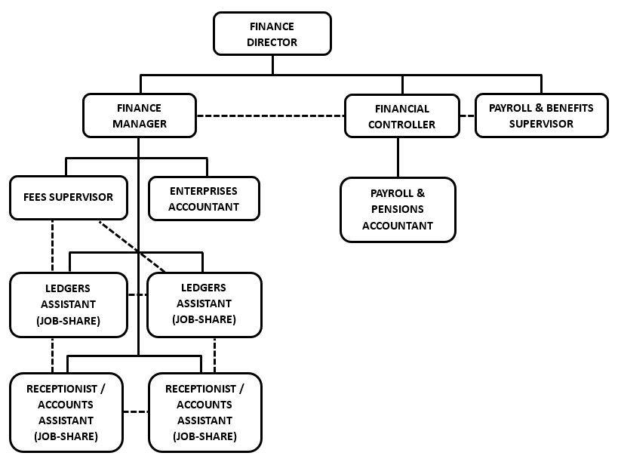

Note
This Role Definition is not an exhaustive list of what may be expected of you in the role. It is non-contractual and may be amended by the School from time to time.

Applications

Applicants should complete the School’s application form, which can be obtained from the website (www.uppingham.co.uk) and returned, when completed, to hr@uppingham.co.uk, 01572 822216.

The HR Department
Uppingham School
High Street West
Uppingham
Rutland
LE15 9QD

