Job Description
Job Title: Graduate Sports Performance Coach (Netball)
Reports to: Head of Netball

Job context

Uppingham School is a co-educational, boarding and day school serving 850 pupils aged 11-18. The teaching staff number 120. Teachers are supported by professional services departments responsible for grounds and gardens, commercial enterprises, marketing, business development, human resources, IT, finance, health and safety, health care, operational services, and estates. Uppingham School has the highest ambitions. We aim to be the school of first choice in the UK and believe that our holistic educational philosophy encapsulates what twenty-first century education ought to be.
Uppingham School has a strong sporting tradition and prides itself on offering a variety of sports to its pupils, as well as offering an enjoyable experience that enables all pupils to develop their athletic skills and ignite their passion for sport.

Uppingham School’s vision for sport includes delivering a sport and physical activities programme that is inclusive, flexible, and supportive of our pupils’ needs. This vision also allows for the elite to achieve their potential, to receive expert coaching and to be linked up with the appropriate player pathways.

The appointed Coach will support the Sports Department in the delivery of the netball programme and general sporting provision at the school. They will be expected to lead a team, designing their sessions so that they are safe, engaging, and appropriate to the players they are coaching. They will also be expected to support prep school and wider outreach programmes and play a part in the overall promotion and success of Uppingham Sport, as well as to be involved in the boarding life of the school.
The postholder will have the opportunity to work directly with former England internationals Hannah Joseph and Jo Welch. Hannah has won three trophies in her 15-year spell with Loughborough Lightning, winning the NSL in 2021, 2023 and 2024. On the international stage, Hannah earned her first cap with England in 2016. Jo played for her country for 9 years whilst still working in education and is an integral part of our programme.
Job purpose
To develop young netballers in a number of different areas: technically, physically, tactically and mentally. To provide clear and considered opportunities for individual and team development and achievement, respecting both the values of the school and the vision and ethos of the school sports programme.
Your accountabilities
- To lead, manage and deliver netball (and other sports) sessions across all age grades: ensure that the sessions are well-planned, goal-orientated and communicated such that players develop their skills, knowledge and understanding of the game. The established coaching environment should be focussed on individual and team progression. There should be regular communication between the Head of Netball and the postholder as regards specific priorities.
- Monitor and develop aspirational pupils: enable our most aspirational players to develop their strengths and identify areas for further development. Sessions may be done on a 1-1 or small group basis. Assist these players, both within and outside of coaching sessions, to set their own goals and give them the tools to be able to effectively reflect on their development and progression in their respective game. Involvement in the scholars’ programme.
- Manage the planning and organisation involved in match days: ensure that teams are selected and published in line with school protocol, and that both selected and non-selected players are communicated with effectively and appropriately. Liaise with the Sports Administration team to ensure that all selection and logistical details are available on SOCS. Ensure that pupils set the highest standards in term of kit and behaviour both on and off the field.
- To conform to the staff code of conduct: coaches are expected to ensure their professional conduct meets the standard articulated by the school in the staff code of conduct.
- To meet all safeguarding responsibilities: as directed by the school’s policies relevant to safeguarding the welfare of children and young people. This includes promoting the school’s policies on equality, diversity, and inclusion (EDI).
- To support the school’s admissions department, marketing, and brand presentation: where required, support the outreach work of the Admissions Department alongside engagement with the school’s Marketing Department to enhance the school’s external and internal communications. This may include providing information, contributing to visual media, delivering coaching sessions, officiating or attending events.
- To ensure that Uppingham’s provision is in line with Health and Safety protocols: ensuring pupil safety and pupil welfare are paramount when carrying out work duties, and that working environments are in line with the school’s safety protocols. All coaching is in line with the school’s health and safety protocols with player safety and welfare at the forefront of our practice. Furthermore, to ensure all sporting activity is in line with National Governing Body guidance and age grade protocols.

Qualifications, skills and experience, personal qualities required
Qualifications
- Qualification in netball coaching (or in other sports) or other vocational qualifications relevant to sport
- Educated to degree level (or equivalent)
Skills and experience
- Experience of coaching, and of leading a team
- Experience of working with young people
- Experience with club and/or national player pathways and/or the professional game
Personal qualities
- Effective communication skills, both interpersonal and public
- Decisive and confident in organisational management
- Personable, supportive, and able to motivate and work in a team
Key relationships
- Assistant Head Co-curricular
- Director of Sport
- Deputy Directors of Sport
- Head of Netball
- Netball Performance Coach
- Woodfield Health Centre medical team
- Housemasters/mistresses
- House Matrons
- Marketing
- Admissions

Benefits

Holidays
The annual holiday entitlement is all Uppingham School holidays, although coaches will be required to work limited reasonable time during the holidays at key periods, as designated by the Headmaster. No holiday may be taken during term time. Public holidays that fall within term time are normal working days.

Other Benefits
- 50% contribution to premiums for the School’s private health scheme
- Free Westfield Healthcare
- Free membership of dual-use Sports Centre (£25 annual joining fee)
- Free staff lunches in term-time
- School fee discount for children of Uppingham staff (pro-rated for part-time staff)
- Retail, gym, supermarket, cinema and restaurant discounts
- Cycle to work scheme
- Employee Assistance Programme
- Occupational Health Services
- Free annual flu jabs
- Recognised as a “Disability Confident” employer
- Recognised as a “Mindful” employer
- Favourable rates and terms with local nursery
- Complimentary staff ticket to selected School performances
- Discount at local coffee shop for Uppingham staff.

Safeguarding
The post-holder’s responsibility for promoting and safeguarding the welfare of children and young persons for whom they are responsible, or with whom they come into contact, will be to adhere to and always ensure compliance with the School’s Safeguarding (Child Protection) Policy. If, while carrying out the duties of the post, the post-holder becomes aware of any actual or potential risks to the safety or welfare of children in the School, they must report any concerns to the School’s Designated Safeguarding Lead or to the Headmaster.

Organisation chart
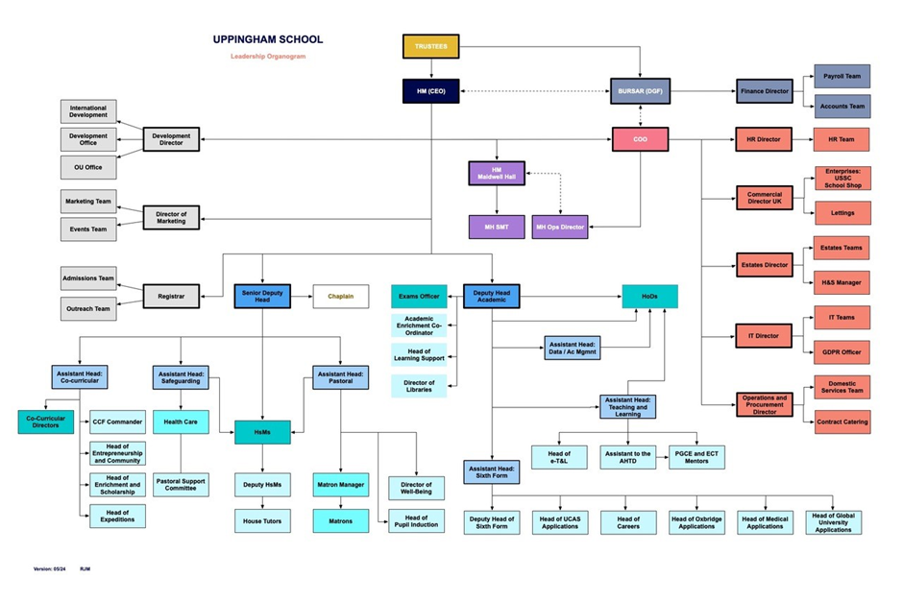

Note

This role description is not an exhaustive list of what may be expected from any member of staff in the course of their work. The role description is non-contractual and may be amended by the school from time to time.

