UPPINGHAM SCHOOL

JOB DESCRIPTION

Job Title
Assistant Housemaster / Housemistress (Resident)

Reports to
Housemaster / Housemistress

Job Context and Background to the School
Uppingham School is a co-educational, full boarding school serving pupils aged 13–18. Boarding lies at the heart of the School’s ethos and pastoral philosophy and is central to pupils’ experience, wellbeing, discipline and personal development. Each boarding house operates as a close-knit residential community in which pupils are cared for, supported and guided throughout term time, twenty-four hours a day.
Boarding houses are at the centre of school life. Pupils eat the majority of their meals in house, are supported academically and pastorally through the house team, and experience house life as their primary community within the School. Each house typically comprises pupils from a range of backgrounds, cultures and nationalities and plays a vital role in shaping pupils’ character, wellbeing and sense of belonging.
Each house is led by a Housemaster/Housemistress and supported by an Assistant Housemaster/Housemistress, matrons, tutors and domestic staff. Together, the house team works collaboratively to ensure that pupils are safeguarded, well cared for, healthy, happy, and supported to thrive academically, socially and personally.
This is a residential position. The Assistant Housemaster/Housemistress is required to live in School-provided accommodation within the boarding house. The residential nature of the role is fundamental, requiring a highly visible and accessible presence in daily house life, evenings, nights and weekends, and enabling continuity of leadership, effective safeguarding oversight and high-quality pastoral care.
The Assistant Housemaster/Housemistress is a key senior role within the house leadership team, deliberately combining responsibilities traditionally associated with the Deputy Housemaster/Housemistress and Matron roles. The post-holder provides expert pastoral, safeguarding, health, residential and operational leadership and ensures that the house functions smoothly, calmly and in full compliance with statutory and regulatory requirements.

Job Purpose
To support the Housemaster/Housemistress in the leadership and day-to-day management of the boarding house, deputising in their absence, and to ensure that the house is run in an orderly, effective and legally compliant manner.
The Assistant Housemaster/Housemistress plays a central role in safeguarding pupils; delivering outstanding pastoral care; overseeing health, welfare and daily routines; promoting positive behaviour; fulfilling tutoring responsibilities to a high professional standard; and ensuring that pupils have full access to the educational and co-curricular opportunities of the School.

Key Accountabilities

1. Safeguarding and Child Protection
- To ensure safeguarding is central to all aspects of boarding house life, planning and decision-making.
- To ensure that pupils feel safe, known and confident to raise concerns or seek support.
- To support the Housemaster/Housemistress in clearly defining and reinforcing safeguarding responsibilities for all house staff and senior pupils.
- To ensure School safeguarding, behaviour, anti-bullying, substance misuse, health and safety, e-safety and pastoral policies are consistently implemented within the house.
- To respond promptly, professionally and proportionately to safeguarding and welfare concerns and ensure accurate recording, referral and escalation in line with School procedures.
- To contribute to a strong safeguarding culture characterised by professional vigilance, openness and accountability.

2. Pastoral Care, Behaviour and Pupil Welfare
- To provide high-quality, day-to-day pastoral care for pupils, maintaining a detailed understanding of individual circumstances, needs and wellbeing.
- To support pupils’ induction, settling-in and key transition points.
- To act as a trusted adult presence and key point of contact for pupils seeking advice, reassurance or guidance.
- To promote positive behaviour, discipline, routines and boundaries consistent with School expectations and the House Handbook.
- To work closely with tutors, matrons, pastoral specialists and senior leaders to identify concerns early and implement appropriate support strategies.
- To encourage pupils’ engagement in academic, co-curricular and community life within the house.

3. Health Care, Welfare and Medical Liaison
- To take a leading role in responding to pupil illness or injury within the house.
- To manage minor medical conditions and exercise professional judgement regarding referral to the Health Centre.
- To liaise closely with the Health Centre and Lead Nurse, ensuring clear communication, appropriate referral and follow-up.
- To oversee the safe storage, administration and recording of medication in accordance with School protocols.
- To promote healthy daily routines, including sleep, nutrition, hygiene and emotional wellbeing.
- To ensure first aid provision and welfare resources within the house are current, appropriate and well maintained.

4. Residential and Operational Management of the House
- To support the Housemaster/Housemistress in the effective leadership and daily management of the boarding house as a residential community operating twenty-four hours a day.
- To take a leading role in overseeing house routines, ensuring clarity, consistency and calm in callovers, attendance, punctuality, meals, uniform standards, prep, bedtimes and night-time arrangements.
- To maintain a highly visible and accessible presence in the house, particularly at key pressure points of the day (mornings, evenings and weekends).
- To ensure the smooth running of evenings, weekends and overnight periods, including supervision, staff deployment, handovers and incident response.
- To work in close partnership with matrons to ensure seamless integration of pastoral, medical and domestic care.
- To oversee standards of accommodation, cleanliness, laundry, catering and presentation of the house, addressing issues promptly and professionally.
- To liaise with estates, maintenance, catering and operational teams to ensure premises are safe, compliant, well maintained and welcoming.
- To support organisation of the house at the beginning and end of term and during house or whole-school events and activities.
- To ensure operational practice reflects School policies, the House Handbook and regulatory requirements at all times.

5. Staff Leadership and Team Working
- To act as a senior member of the house leadership team, providing clarity, direction and support to tutors, matrons and domestic staff.
- To contribute to staff deployment, supervision and line management, particularly when deputising for the Housemaster/Housemistress.
- To ensure effective communication, handover and record-keeping across the house team.
- To support staff induction, professional standards and ongoing development.

6. Tutoring and Academic Support
Assistant Housemasters/Housemistresses are expected to act as House Tutors and to model best practice in tutoring as a core element of their pastoral and professional leadership.
- To take primary responsibility for the academic, pastoral and personal development of pupils in their tutor group, knowing each tutee well as an individual.
- To meet regularly on a one-to-one basis with each tutee, providing guidance, support, appropriate challenge and encouragement.
- To act as one of the first and most consistent points of contact between home and school for pupils in their care.
- To promote ambition, independence and effective learning habits and support pupils in managing the demands of school life.
- To use assessment information, reports and feedback effectively to support progress and identify concerns early.
- To work closely with subject teachers, Heads of Department, academic support services and house staff to coordinate support and intervention.
- To encourage pupils’ wider development through co-curricular involvement, leadership opportunities and contribution to house life.
- To contribute to sixth form guidance where relevant, including subject choices, references and post-school planning.
- To ensure tutoring records and communications are accurate, timely and professionally maintained.

7. Communication with Parents and Guardians
- To support clear, timely and professional communication with parents and guardians.
- To act as a point of contact for parents in agreed areas, particularly relating to welfare, health, tutoring and day-to-day matters.
- To build strong, trusting relationships between families and the boarding house.
- To contribute to written and verbal communication including reports, meetings and house communications.

8. Deputising, Duty and Compliance Responsibilities
- To deputise for the Housemaster/Housemistress as required, ensuring continuity of leadership, decision-making and care.
- To take responsibility for the house during designated duty periods, including evenings, nights and weekends.
- To assume lead responsibility for safeguarding, health and safety, fire procedures and staff coordination when in charge of the house.
- To be fully conversant with the National Minimum Standards for Boarding Schools and associated statutory requirements.
- To ensure house systems and records are inspection-ready at all times.
- To contribute actively to audits, reviews, inspections and continuous improvement.

Outcomes
The Assistant Housemaster/Housemistress will be successful in the role when the following outcomes are consistently evident in day-to-day practice and in the lived experience of pupils, staff and parents:

Safeguarding and Welfare
- Safeguarding is central to all aspects of house life and decision-making.
- Pupils feel safe, supported and confident to raise concerns.
- Safeguarding issues are identified early, managed appropriately and recorded accurately.
- Staff apply safeguarding procedures consistently and confidently.

Pastoral Care and Pupil Experience
- Pupils are known well as individuals and feel valued, supported and listened to.
- Behaviour is positive, respectful and appropriate to a residential community.
- Transitions and difficulties are managed calmly and compassionately.

Health, Medical and Welfare Provision
- Health needs are addressed promptly and professionally.
- Communication with the Health Centre is clear and effective.
- Medication and welfare records are accurately maintained.

Residential Life and Routines
- Daily routines are calm, predictable and consistently applied.
- Evenings, weekends and nights are well supervised and orderly.
- The house environment is safe, welcoming and conducive to rest and study.

Tutoring and Academic Guidance
- Tutor–tutee relationships are strong, professional and supportive.
- Pupils understand their academic progress and how to improve.
- Academic concerns are identified early and addressed effectively.

Staff Leadership and Professional Practice
- House staff feel supported, informed and clear about expectations.
- Communication and teamwork within the house are strong.
- Leadership is confident and consistent during duty periods and absences.

Parental Confidence and Communication
- Parents feel informed, reassured and confident in the care provided.
- Communication is timely, professional and solution-focused.

Compliance and Inspection Readiness
- House systems and records are consistently inspection-ready.
- Statutory and regulatory requirements are fully met.
- The house contributes positively to the School’s wider pastoral culture and reputation.

Qualifications, Skills and Personal Qualities

Qualifications and Experience
- Experience of pastoral care within a boarding, residential or school setting.
- First Aid qualification (or willingness to undertake).
- Experience of tutoring or mentoring adolescents.
- Sound knowledge of safeguarding and welfare procedures.

Skills and Attributes
- Strong pastoral instincts combined with authority and sound professional judgement.
- Excellent communication, organisation and record-keeping skills.
- Calm, resilient and professional under pressure.
- Commitment to safeguarding, inclusion and high standards of care.
- Willingness to live and work as part of a residential community.

Safeguarding Statement
The post-holder has a specific responsibility for promoting and safeguarding the welfare of children and young people and must comply fully with the School’s Safeguarding (Child Protection) Policy. Any safeguarding concerns must be reported immediately to the Designated Safeguarding Lead.

Note: This job description is not exhaustive and may be reviewed and amended in line with the evolving needs of the School.

Operating environment

Whilst each boarding house will have its own unique ‘character’, housemasters/mistresses will be responsible for running their allocated boarding house in a collaborative and integrated way with his/her peers to ensure sufficient consistency in boarding house provision and full compliance with all regulations relating to boarding and safeguarding; the job-holder is pivotal in ensuring that Safeguarding is at the centre of all activity within the House.

The most challenging feature of this role is to identify and meet the needs of each and of all students, which may be complex, profound and compounded by learning difficulties, language difficulties, cultural difficulties and the intensity of boarding life whilst providing a sense of community, inclusion and above all safety and security. All staff within the House must work collaboratively and collectively to support the delivery of an outstandingly good health and welfare service and boarding experience for all pupils in their care.

Boarding house staff are in loco parentis (both legally and pastorally), for that reason the job-holder is expected to role model extremely high standards of personal behaviour and ensure the same from each and every member of the team; all are visible role models for our pupils. Staffs’ care of students extends beyond the boarding house and they play a fundamental role in their total welfare and wellbeing, helping them develop into self-confident and purposeful young adults, pass through key stages of their physical and emotional development and prepare to enter the wider world beyond school as well rounded citizens. Each child is unique and must be cared for accordingly, whilst always bearing in mind perceptions of fairness and consistency in approach.

Staff work is often physically and mentally demanding, hours can be extended and long and there is a constant pressure throughout the term time from individual and groups of pupils. Balancing house demands with the demands of the wider school activities (academic and social) can require great flexibility and co-operative working with colleagues outside the boarding environment. The Housemaster/mistress is key is ensuring the staff within his/her control are motivated, engaged, trained and competent and feel supported in the delivery of their accountabilities.

Key Relationships
- Headmaster
- Senior Deputy Head
- Deputy Head Academic
- Assistant Head Pastoral
- Assistant Head Safeguarding
- Assistant Head Data and Academic Management
- Assistant Head Sixth Form
- Assistant Head Co-curricular
- Matron Manager
- SENDCO
- HoDs & Academic staff
- Health Centre and School counselling services

Benefits
Standard list available from HR, as relevant to role.

- Accommodation provided free of all costs
- A salary allowance is attached to the role (see Teaching Pay Document for details)
- Either one academic period per week or equivalent reduction in extra-curricular commitments (should academic timetable reduction not be possible)

NOTE: The exact nature of the remission (i.e. whether academic or extra-curricular based) would be determined on an annual basis as part of the process of constructing the overall teaching timetable.

Notice period

Deputy housemasters/mistresses are requested to inform the Senior Deputy Head of their intention to resign their position by the first day of the summer term in the year they wish to cease the position.

Safeguarding

The post-holder’s responsibility for promoting and safeguarding the welfare of children and young persons for whom s/he is responsible, or with whom s/he comes into contact, will be to adhere to and ensure compliance with the School’s Safeguarding (Child Protection) Policy at all times. If in the course of carrying out the duties of the post the post-holder becomes aware of any actual or potential risks to the safety or welfare of children in the School s/he must report any concerns to the School’s Designated Safeguarding Lead or to the Headmaster.

Organisation Chart

Note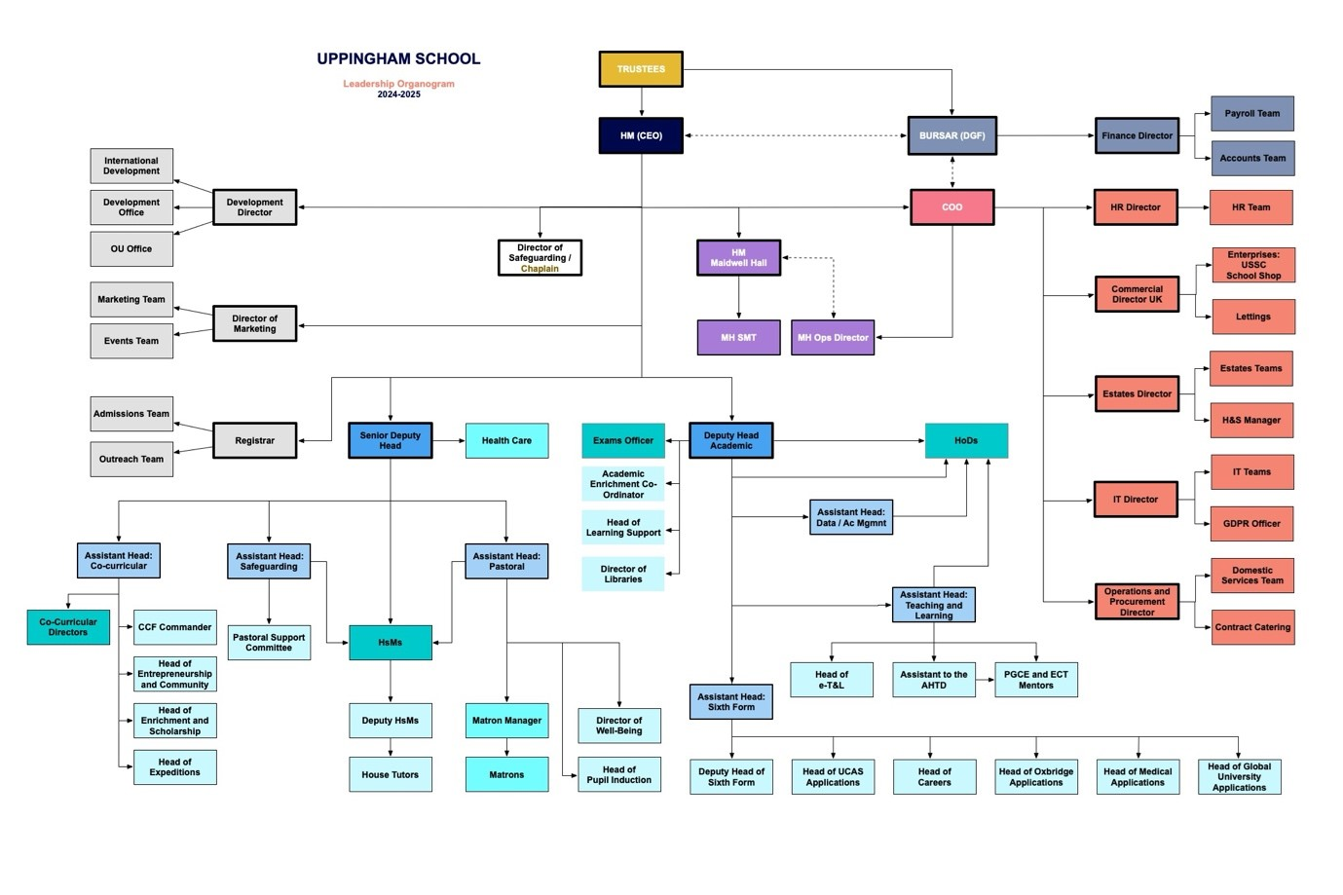
Note
This Job Description is not an exhaustive list of what may be expected of you in the role. It is non-contractual and may be amended

